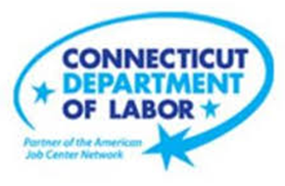

**NEW WEEKLY JOB POSTINGS FROM   
HELP WANTED ONLINE  
Office of Research**

**Week Ending December 10th, 2022:   
Total New Ads Continue Rebound From Thanksgiving Holiday Low.**WETHERSFIELD, December 16th, 2022 – During the week ending December 10th, there were 6,410 new postings, up 491 new ads or +8% over the week. Half of this overall increase occurred in Manufacturing (+117 new ads) and Health Care & Social Assitance (+106 new ads). Within Manufacturing, the occupation with the most ads was Mechanical Engineer (36 new ads) and the employer with the most new ads was Ratheon (68 new ads). Within Health Care & Social Asistance, Registered Nurses (248 new ads) had the most new occupational job ads and the employer with the most was Community Health Center, Inc. (206 new ads). The graph below illustrates how total new ads are rebounding in Connectict and the United States from a drop that occurred last month around the Thanksgiving holiday.   
  
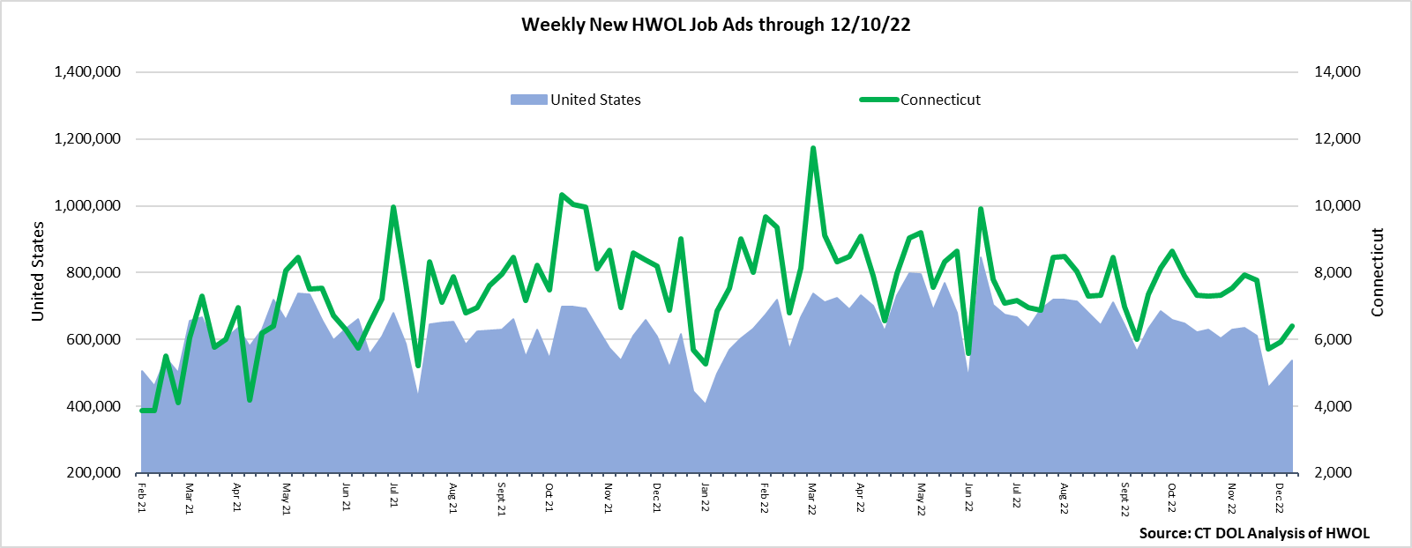  
**Industries** with the most new postings include Health Care & Social Assistance, Manufacturing, and Retail Trade.

**Occupations** with the most new postings include Registered Nurses, Retail Salespersons, and Supervisors of Retail Sales Workers.

**Employers** with the most new postings include Community Health Center Inc., Yale-New Haven Health System, and Hartford Healthcare.

**The three industries with the most new job postings were:**

* **Health Care & Social Assistance** (1,665 new postings, +7% over the week)
* **Manufacturing** (573 new postings, +26% over the week)
* **Retail Trade** (508 new postings, +3% over the week)

   
 During the week ending December 10th, 2022, the 8% new ad total increase is the net result of increases in twelve industries and decreases in nine industries. The twelve increasing industries grew by a combined 747 new ads and the largest industry increases occurred in Manufacturing (+117 new ads), Health Care (+106 new ads) and Administrative & Support (+65 new ads). The nine decreasing industries fell by a combined 256 new ads, Accommodation & Food Services was down the most (-136 new ads). Over four weeks, total ads were down 19% or ‑1,524 new ads, sixteen industries were down, one was unchanged, and four were up. Half of the overall decline occurred in Educational Services (-770 new ads). The largest four-week industry increase occurred in Health Care (+217 new ads).  
  
 For more information on total job ads by industry for Connecticut and its labor market areas, see the monthly report available here: <https://www1.ctdol.state.ct.us/lmi/hwol.asp>

**New Job Postings by Occupation** 

**The occupations with the most new postings were:**

* Registered Nurses (344 new postings, +2% over the week)
* Retail Salespersons (159 new postings, -6% over the week)
* Supervisors of Retail Sales Workers (128 new postings, -6% over the week)

**Employers with the Most New Job Postings**  Employers with the most new job postings during the week were mostly in Healthcare & Social Assistance, Manufacturing, and Retail Trade. The 25 employers shown above account for 18 percent of all new ads. 18 of 25 employers in the top 25 increased over the week, seven decreased. The top 25 employers with the largest over the week increase and decrease respectively were Hartford Healthcare. (+123 new ads) and Community Health Center, Inc. (-101 new ads).   
  
**What is HWOL?**The **Conference Board Help Wanted Online**® Data Series (HWOL) measures the number of new, first-time Online job postings and jobs reposted from the previous month for over 16,000 Internet job boards, corporate boards, and smaller job sites that serve niche markets and smaller geographic areas. To view more HWOL data, go to: <https://www1.ctdol.state.ct.us/lmi/hwol.asp>